Experiment – 6

Server-side Validation using PHP

What is PHP?
PHP is a server side scripting language. that is used to develop Static websites or Dynamic websites or Web applications. PHP stands for Hypertext Pre-processor, that earlier stood for Personal Home Pages. PHP scripts can only be interpreted on a server that has PHP installed.
The client computers accessing the PHP scripts require a web browser only.
A PHP file contains PHP tags and ends with the extension ".php".

Architecture of a PHP Application

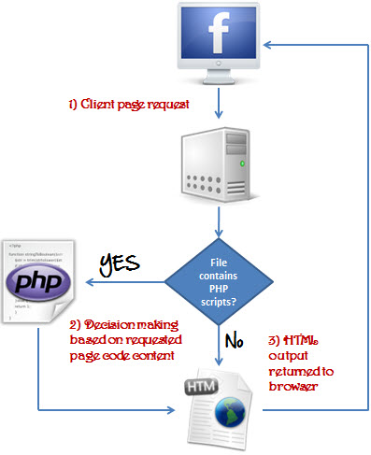

PHP Hello world

<!DOCTYPE html>
<html>
<body>
<?php
echo "My first PHP script!";
?>
</body>
</html>

Link to study PHP details
https://www.w3schools.com/PHP/default.asp

https://www.guru99.com/case-study-opinion-poll-app.html

Assignment 1
- Create an opinion poll application consisting of following screens. Poll may be regarding any topic other than Javascript library.

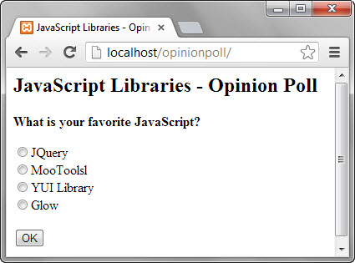

If you click on the Ok button without selecting a JS library, you will get the following message box.

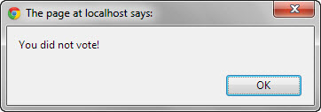

Select a JS library then click on OK button. You will get the results page similar to the one shown below.
